# BIOL 4150 Assignment 5

1.

**Table 1:** A representation of the Leslie Matrix showing the survival rates and fecundity of Red Pandas across 5 age classes: <1, 1, 2, 3, >3.

|  |  |  |  |  |
| --- | --- | --- | --- | --- |
| 0.0 | 1.065 | 1.892 | 1.666 | 0.112 |
| 0.4 | 0.000 | 0.000 | 0.000 | 0.000 |
| 0.0 | 0.710 | 0.000 | 0.000 | 0.000 |
| 0.0 | 0.000 | 0.860 | 0.000 | 0.000 |
| 0.0 | 0.000 | 0.000 | 0.490 | 0.140 |

2a)

> p <- c(0.40,0.71,0.86,0.49,0.14)

> m <- c(0.0,1.5,2.2,3.4,0.8)

> A <- matrix(0,nr=5,ncol=5)

> A[1,1] <- p[1]*m[1]

> A[1,2] <- p[2]*m[2]

> A[1,3] <- p[3]*m[3]

> A[1,4] <- p[4]*m[4]

> A[1,5] <- p[5]*m[5]

> A[2,1] <- p[1]

> A[3,2] <- p[2]

> A[4,3] <- p[3]

> A[5,4] <- p[4]

> A[5,5] <- p[5]

> tmax <- 11

> t <- 1:tmax

> n1 <- matrix(0,nr=5,ncol=tmax)

> n1[,1] <- c(10,0,0,0,0)

> for(i in (1:(tmax-1))) {n1[,i+1] <- A%*%n1[,i]}

> n1

[,1] [,2] [,3] [,4] [,5] [,6] [,7] [,8] [,9]

[1,] 10 0 4.26 5.37328 5.883798 4.7120735 7.1458877 7.4150089 8.0506021

[2,] 0 4 0.00 1.70400 2.149312 2.3535194 1.8848294 2.8583551 2.9660036

[3,] 0 0 2.84 0.00000 1.209840 1.5260115 1.6709987 1.3382289 2.0294321

[4,] 0 0 0.00 2.44240 0.000000 1.0404624 1.3123699 1.4370589 1.1508768

[5,] 0 0 0.00 0.00000 1.196776 0.1675486 0.5332834 0.7177209 0.8046398

[,10] [,11]

[1,] 9.0059598 10.3973144

[2,] 3.2202408 3.6023839

[3,] 2.1058625 2.2863710

[4,] 1.7453116 1.8110418

[5,] 0.6765792 0.9499238

> N1 <- numeric(tmax)

> for(i in (1:tmax)) {N1[i] <- sum(n1[,i])}

> N1[tmax]

[1] 19.04703

>

> n2 <- matrix(0,nr=5,ncol=tmax)

> n2[,1] <- c(0,10,0,0,0)

> for(i in (1:(tmax-1))) {n2[,i+1] <- A%*%n2[,i]}

> n2

[,1] [,2] [,3] [,4] [,5] [,6] [,7] [,8]

[1,] 0 10.65 13.4332 14.70950 11.7801837 17.864719 18.537522 20.126505

[2,] 10 0.00 4.2600 5.37328 5.8837984 4.712073 7.145888 7.415009

[3,] 0 7.10 0.0000 3.02460 3.8150288 4.177497 3.345572 5.073580

[4,] 0 0.00 6.1060 0.00000 2.6011560 3.280925 3.592647 2.877192

[5,] 0 0.00 0.0000 2.99194 0.4188716 1.333208 1.794302 2.011600

[,9] [,10] [,11]

[1,] 22.514900 25.993286 28.214850

[2,] 8.050602 9.005960 10.397314

[3,] 5.264656 5.715927 6.394231

[4,] 4.363279 4.527604 4.915698

[5,] 1.691448 2.374809 2.551000

> N2 <- numeric(tmax)

> for(i in (1:tmax)) {N2[i] <- sum(n2[,i])}

> N2[tmax]

[1] 52.47309

>

> n3 <- matrix(0,nr=5,ncol=tmax)

> n3[,1] <- c(0,0,10,0,0)

> for(i in (1:(tmax-1))) {n3[,i+1] <- A%*%n3[,i]}

> n3

[,1] [,2] [,3] [,4] [,5] [,6] [,7] [,8]

[1,] 0 18.92 14.3276 8.531888 16.3358789 19.041076 17.628359 20.588613

[2,] 0 0.00 7.5680 5.731040 3.4127552 6.534352 7.616430 7.051344

[3,] 10 0.00 0.0000 5.373280 4.0690384 2.423056 4.639390 5.407666

[4,] 0 8.60 0.0000 0.000000 4.6210208 3.499373 2.083828 3.989875

[5,] 0 0.00 4.2140 0.589960 0.0825944 2.275863 2.033314 1.305740

[,9] [,10] [,11]

[1,] 24.534359 26.230285 28.976268

[2,] 8.235445 9.813744 10.492114

[3,] 5.006454 5.847166 6.967758

[4,] 4.650592 4.305550 5.028563

[5,] 2.137842 2.578088 2.470652

> N3 <- numeric(tmax)

> for(i in (1:tmax)) {N3[i] <- sum(n3[,i])}

> N3[tmax]

[1] 53.93535

>

> n4 <- matrix(0,nr=5,ncol=tmax)

> n4[,1] <- c(0,0,0,10,0)

> for(i in (1:(tmax-1))) {n4[,i+1] <- A%*%n4[,i]}

> n4

[,1] [,2] [,3] [,4] [,5] [,6] [,7] [,8]

[1,] 0 16.66 0.5488 7.173992 9.1964298 10.1315301 8.2192943 12.2153047

[2,] 0 0.00 6.6640 0.219520 2.8695968 3.6785719 4.0526120 3.2877177

[3,] 0 0.00 0.0000 4.731440 0.1558592 2.0374137 2.6117861 2.8773545

[4,] 10 0.00 0.0000 0.000000 4.0690384 0.1340389 1.7521758 2.2461360

[5,] 0 4.90 0.6860 0.096040 0.0134456 1.9957112 0.3450786 0.9068772

[,9] [,10] [,11]

[1,] 12.789007 13.880223 15.511255

[2,] 4.886122 5.115603 5.552089

[3,] 2.334280 3.469147 3.632078

[4,] 2.474525 2.007480 2.983466

[5,] 1.227569 1.384377 1.177478

> N4 <- numeric(tmax)

> for(i in (1:tmax)) {N4[i] <- sum(n4[,i])}

> N4[tmax]

[1] 28.85637

>

> n5 <- matrix(0,nr=5,ncol=tmax)

> n5[,1] <- c(0,0,0,0,10)

> for(i in (1:(tmax-1))) {n5[,i+1] <- A%*%n5[,i]}

> n5

[,1] [,2] [,3] [,4] [,5] [,6] [,7] [,8]

[1,] 0 1.12 0.1568 0.499072 0.6716774 0.75302026 0.63317507 0.88898393

[2,] 0 0.00 0.4480 0.062720 0.1996288 0.26867098 0.30120810 0.25327003

[3,] 0 0.00 0.0000 0.318080 0.0445312 0.14173645 0.19075639 0.21385775

[4,] 0 0.00 0.0000 0.000000 0.2735488 0.03829683 0.12189335 0.16405050

[5,] 10 1.40 0.1960 0.027440 0.0038416 0.13457674 0.03760619 0.06499261

[,9] [,10] [,11]

[1,] 0.95493875 1.0353589 1.15361774

[2,] 0.35559357 0.3819755 0.41414354

[3,] 0.17982172 0.2524714 0.27120261

[4,] 0.18391767 0.1546467 0.21712544

[5,] 0.08948371 0.1026474 0.09014751

> N5 <- numeric(tmax)

> for(i in (1:tmax)) {N5[i] <- sum(n5[,i])}

> N5[tmax]

[1] 2.146237

**Table 2:** A summary of total populations of Red Pandas after a 10-year growth period given 5 different starting populations.

|  |  |
| --- | --- |
| Total population in 2019 | Total population in 2029 |
| 10 (all < 1 year old) | 19.047 (~19) |
| 10 (all 1 year old) | 52.473 (~52) |
| 10 (all 2 years old) | 53.935 (~53) |
| 10 (all 3 years old) | 28.856 (~28) |
| 10 (all > 3 years old) | 2.146 (~2) |

Note: I set tmax = 11 so that we could get the values for between 2019 and 2029, if tmax was = 10 it would only include 2019:2028 inclusive. Additionally, total population numbers were rounded down to the nearest whole number, as a percentage of an animal does not make sense in nature.

2b)

Based on the results from above, the age class of 2 years is the most appropriate for relocation if the goal is to maximize population growth over the next 10 years. This age class results in faster population growth compared to the other classes, as this class not only has the highest transitioning survival percentage (86%, shown in the matrix in #1), but also has the highest age-specific fecundity (1.892, shown in the matrix in #1). This means that not only are more individuals surviving at this age than at other ages, but this age has the highest levels of fecundity, and therefore population growth.

3a)

> ###for n3 (where the starting population is 10 individuals in age group 2)

> tmax2 <- 20

> t <- 1:tmax2

> n3 <- matrix(0,nr=5,ncol=tmax2)

> n3[,1] <- c(0,0,10,0,0)

> for(i in (1:(tmax2-1))) {n3[,i+1] <- A%*%n3[,i]}

> N3 <- numeric(tmax2)

> for(i in (1:tmax2)) {N3[i] <- sum(n3[,i])}

>

> w <- matrix(0,nr=5,ncol=tmax2)

> for(i in (1:tmax2)){w[,i] <- n3[,i]/N3[i]}

>

> plot(t-1,w[1,],type='l',col='orange3',lwd=3,xlab='Time',ylab='W',ylim=c(0,1))

>

> lines(t-1,w[2,],lwd=3,lty=2,col='forestgreen')

> lines(t-1,w[3,],lwd=4,lty=3,col='brown1')

> lines(t-1,w[4,],lwd=3,lty=4,col='darkmagenta')

> lines(t-1,w[5,],lwd=3,lty=5,col='khaki')

> legend(1.5,1,c("<1",'1','2','3','>3'),col=c('orange3','forestgreen','brown1','darkmagenta','khaki'),lty=1:5,lwd=c(3,3,4,3,3),bty='n')

>

> w[,20]

[1] 0.54038457 0.19377103 0.12317670 0.09491850 0.04774919

Therefore, the stable age distribution for red pandas will be as follows:

|  |  |
| --- | --- |
| **AGE GROUP** | **PROPORTION OF POPULATION** |
| <1 | 0.540 |
| 1 | 0.194 |
| 2 | 0.123 |
| 3 | 0.095 |
| >3 | 0.048 |

3b)

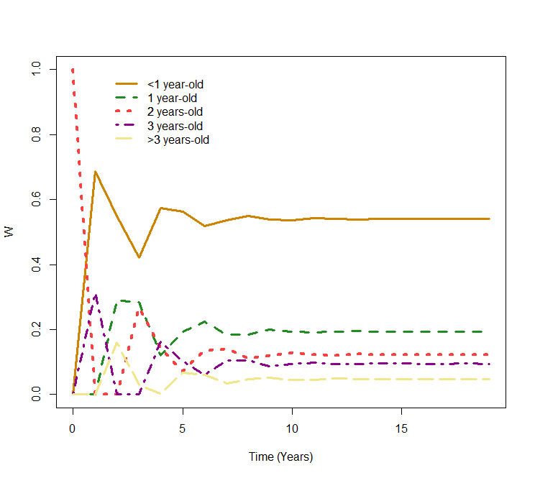

**Figure 1:** A stabilization of the age distribution of red pandas from 2019 to 2039, with an initial population of 10 individuals each at 2 years of age, with 0 individuals at any other age group (<1,1,3,>3). At the end of the measured time period there appears to be a stabilization of the proportions of each of the age classes, with the proportions being as follows: <1 = 0.540; 1 = 0.194; 2 = 0.123; 3 = 0.095; >3 = 0.048.